02 Fire safety policy

Alongside associated procedures in 02.1 Fire safety, this policy was adopted by Little Oak Pre-School (Witney) Limited on 28th July 2021.
Designated Fire Marshalls are: Nicola Godfrey and Naomi Skingsley.

Aim
Our provision is a suitable, clean, and safe place for children to be cared for, where they can grow and learn. We meet all statutory requirements about fire safety and fulfil the criteria for meeting the relevant Early Years Foundation Stage Safeguarding and Welfare Requirements.

Objectives
- We recognise that we have a corporate responsibility and a duty of care for those who work in and receive a service from our provision, but individual employees and service users also have a responsibility to ensure their own safety as well as that of others. Risk assessment is the key means through which this is achieved.
- A fire safety risk assessment is carried out by a competent person in accordance with the Regulatory Reform (Fire Safety) Order 2005.
- A Fire Log is completed and regularly updated.
- Necessary equipment is in place to promote fire safety.

Legal references
Regulatory Reform (Fire Safety) Order 2005)
Electricity at Work Regulations (1989)
Further guidance
Fire Safety Record (Early Years Alliance 2019)
Fire Safety Risk Assessment: Educational Premises www.communities.gov.uk/publications/fire/firesafetyrisk6
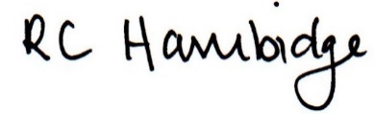

Rosalind Hambidge (Director) Date: 22nd October 2021

Policy review due: April 2022 Position:

Policy review due: Oct 2022 Position

Signed on behalf of Little Oak Pre-school (Witney) Ltd

