09 Childcare practice procedures
09.5 Establishing children’s starting points

When children start at the setting they arrive at different levels of learning and development. In order to help them to settle and make rapid progress it is important that they are provided with care and learning opportunities that are suited to their needs, interests and abilities. This means establishing and understanding their starting points and whether there are any obstacles to their learning, so that teaching can be tailored to the ‘unique child’.
- The aim of establishing a child’s starting points is to ensure that the most appropriate care and learning is provided from the outset.
- Starting points are established by gathering information from the first contact with the child’s parents at induction and during the ‘settling in’ period. Staff do not ‘wait and see’ how the child is settling before they begin to gather information.
- The key person is responsible for establishing their key children’s starting points by gathering information in the following ways:
- observation of the child during settling in visits
- discussion with the child’s parents
- building on information that has been gathered during registration by referring to the registration form
The information gathered is recorded within two weeks of the child’s official start date and sooner where possible.
- The key person must make a ‘best fit’ judgment about the age band the child is working in, referring to Development Matters.
- The key person should complete details by indicating where they have gathered their evidence from, using more than one source where possible i.e. parent comment and observation during settling in.
  - If the initial assessment raises any concerns that extra support may be required procedure 09.13 Identification, assessment and support for children with SEND is followed.
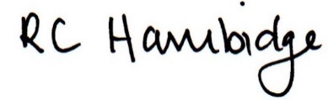
Rosalind Hambidge (Director) Date: 22nd October 2021

Policy review due: April 2022 Position:

Policy review due: Oct 2022 Position

Signed on behalf of Little Oak Pre-school (Witney) Ltd

