01 Health and safety procedures
01.17 Jewellery and hair accessories

Children, staff members, volunteers and students do not attend the setting wearing jewellery or fashion accessories that may pose a potential hazard to other children or themselves.
- Health and safety take precedence over respect for culture, religion or fashion.
- Members of staff do not wear jewellery or fashion accessories, such as belts or high heels, that may pose a danger to them or to young children. These include large rings with sharp edges, earrings - other than studs, chain necklaces, or bracelets with attachments that can be pulled off, or belts with large buckles.
- Parents must ensure that any jewellery worn by children poses no risk, for example, earrings which may get pulled, bracelets which can get caught when climbing, or necklaces that may pose a risk of strangulation.
- Children may wear small, smooth stud earrings.
- Children, staff, and volunteers do not wear anything with sharp edges that could scratch children, or jewellery with small elements that could become detached and swallowed.
- Hair accessories that may come loose pose a choking hazard are removed before children sleep or rest.
- Parents are requested not to send children wearing hair beads. If staff see beads that are coming loose, they will remove them.
- Hair accessories that may pose a choking hazard to other children should they become detached, should be removed if members of staff consider this to be a possibility.
- Amber beads for teething pain relief are not to be worn due to the risk of choking posed to the infant and other children who may remove them.

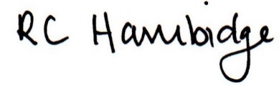

Rosalind Hambidge (Director) Date: 22nd October 2021

Policy review due: April 2022 Position:

Policy review due: Oct 2022 Position
All signed on behalf of Little Oak Pre-school (Witney( Ltd

