06 Safeguarding children, young people and vulnerable adults procedures
06.8 Looked after children

Identification.
A 'Looked after Child' is a child in public care, who is placed with foster carers, in a residential home or with parents or other relatives.

Services provided to Looked After Children
Two-year-olds
- Places will be offered to two-year-old children who are looked after; where the placement in the setting will normally last a minimum of three months.
- Where the child is already in attendance and has a secure attachment with an existing key person a continuation of the existing place will be offered.
Three- and four-year-olds
- Places will be offered for funded three- and four-year -olds who are looked after; where the placement in the setting will normally last a minimum of six weeks.
- If a child who attends a setting is taken into care and is cared for by a local carer the place will continue to be made available to the child.

Additional Support
- The designated person and key person liaise with agencies and professionals involved with the child, and his or her family, and ensure appropriate information is gained and shared.
- A meeting of professionals involved with the child is convened by the setting at the start of a placement. A Personal Education Plan (PEP) for children over 3 years old is put in place within 10 days of the child becoming looked after.
- Following this meeting, 6.8a Care plan for looked after children form is completed. The care plan is reviewed after two weeks, six weeks, three months, and thereafter at three to six monthly intervals.
- Regular contact will be maintained with the social worker through planned meetings, which will include contribution to the PEP which is reviewed annually.
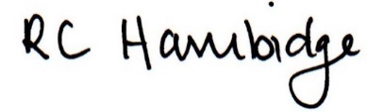
Rosalind Hambidge (Director) Date: 22nd October 2021
Policy review due: April 2022 Position:

Policy review due: Oct 2022 Position
Signed on behalf of Little Oak Pre-school (Witney) Ltd

